# Professional Growth Structure for Interior Design Students

This section introduces practical approaches that support your foundation studies and prepare you for future HNC-level work. These organizational tactics will help you navigate your learning journey effectively, building on the design principles you've already encountered in previous lessons.



Fig.1 (Photo By: Kaboompics.com on [Pexels](https://www.pexels.com/photo/4968713/), 2025) Professional designer demonstrating effective organization systems that support creative workflow while managing multiple projects

## 1. HNC Preparation

### Weekly Study Time Calculation

Ever wonder how top designers seem to have their work-life balance sorted? Here's what they don't always tell you:

1. **Time Allocation Strategy**: Successful designers carve out specific time blocks for different types of work

* When you're immersed in a creative project, you'll need uninterrupted chunks of 2-3 hours

1. **Project Intensity Management**: Design work naturally fluctuates

* During concept development and client presentations, you'll need to ramp up your time commitment
* During research phases, you might work in shorter, more frequent bursts

**Try This when analyzing your productivity patterns:** Examine your actual schedule and spot when you naturally feel most creative versus when you're better at technical tasks. Align your design activities with these energy patterns. Compare notes with a classmate to discover if you have complementary work styles that might benefit future collaborations. Jot down which time blocks consistently produce your best work. Circle your three most productive time slots for future reference.

### Career Development Phases

The design journey goes beyond learning skills—it transforms how you perceive and engage with the world:

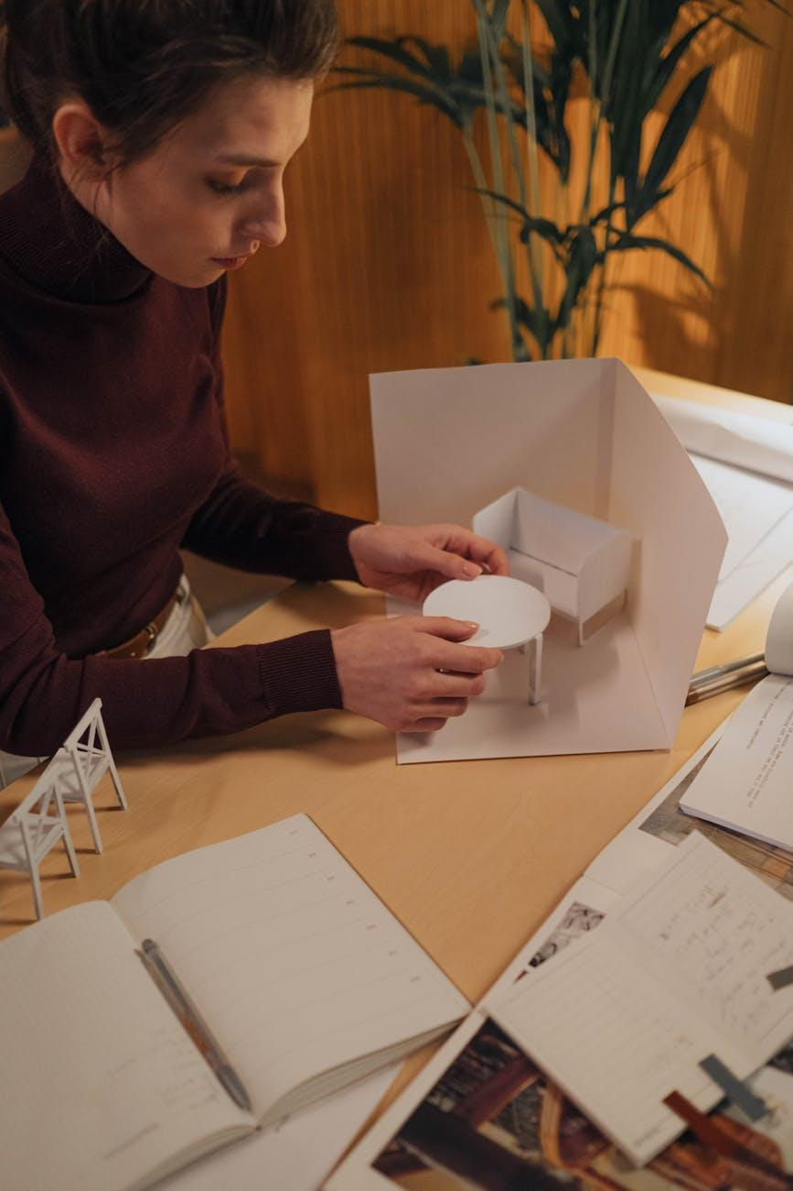

Fig.2 (Ron Lach on [Pexels](https://www.pexels.com/photo/8086369/), 2025) The evolution of an interior design project showing the progression from concept to completion, reflecting the designer's growing professional identity

1. **Foundation Building Phase**

* You're developing your designer's eye—spotting details others overlook
* Each technique you grasp becomes part of your unique toolkit
* The organizational habits forming now will save you countless hours down the road

1. **Portfolio Development Phase**

* Your projects start telling a cohesive story about your design perspective
* You'll begin to identify your natural strengths and preferences
* Documentation becomes instinctive rather than an afterthought

1. **Professional Identity Phase**

* You'll connect with designers whose approach resonates with yours
* Your specialized interests will steer your continuing education choices
* Clients and employers will spot what makes your approach unique

1. **Industry Integration Phase**

* You'll apply classroom concepts to real-world constraints and budgets
* Your professional network will unlock doors to opportunities
* Your confidence in presenting and defending your design decisions will flourish

Each project pushes you further along this path, with your skills becoming sharper and your professional voice more distinct.

## 2. Resource Planning

### Required Materials and Digital Tools

Think of your design toolkit as an extension of your creative mind:



Fig.3 (Luna Lovegood on [Pexels](https://www.pexels.com/photo/4087480/), 2025) Integrated physical and digital design toolkit showing how organized resources support the creative process

1. **Physical Materials Inventory**:

* Set up a simple tracking system for supplies you use regularly
* Build relationships with local suppliers who can help when you need specialized items
* Begin collecting interesting textures and materials that spark ideas

1. **Digital Ecosystem**:

* Create a logical folder structure that evolves with your projects
* Adopt a consistent file naming system that clicks with your thinking
* Configure automatic backups to safeguard your creative work

When you're mid-breakthrough on a design concept, the last thing you want is to be scrambling for that perfect reference image or material sample you know exists somewhere. The organization systems you build now will fuel your creative process rather than derailing it.



Fig.4 (Alena Darmel on [Pexels](https://www.pexels.com/photo/7641896/), 2025) Professional designer presenting concepts to clients, demonstrating how organizational skills translate to confident delivery of design solutions

**Try This while reflecting on your design aspirations:** Considering the career development phases we've explored, which aspects of design work currently give you the most joy? Maybe it's the problem-solving, the visual storytelling, or the way design enhances how people experience spaces. How might your current strengths guide your specialization as you progress? Jot down three keywords that capture your design approach.

The planning strategies introduced here aren't just academic exercises—they're the same methods that enable professional designers to handle multiple clients, deadlines, and creative challenges simultaneously. As your projects grow more complex in the HNC programme, these organizational foundations will help you maintain both quality and sanity.

The most successful designers aren't necessarily the most naturally gifted—they're the ones who develop systems that nurture their creativity and enable them to deliver consistently excellent work. The habits you're forming now are actually your first professional design project: crafting an effective structure for your own creative practice.